DeclarationofConformity(DoC)

We, DOKE COMMUNICATION (HK) LIMITED

19H MAXGRAND PLAZANO 3 TAI YAU STREETSAN PO KONGKL

Declare that the DoCisissuedunder oursole responsibilityandbelongs tothe followingproduct(s): ProductType: smartphone
Trademark： BLACKVIEW
Model Number(s): XPLORE 1 Walkie Talkie, XPLORE 1 Pro
(Nameofproduct,typeormodel,batchorserialnumber) Systemcomponents:
LDS Antenna1:BT/Wi-Fi2.4G:-1.2dBi;WIFI5G:1.2dBi; Antenna2:Wi-Fi2.4G:-0.6dBi;WIFI5G:1.24dBi;
GSM900:-0.44 dBi/DCS1800:2.67dBi
WCDMA:Band Ⅰ:0.92dBi ;Band Ⅷ:-0.44dBi;
LTE:Band 1: 0.92dBi; Band 3: 2.67dBi; Band 7:1.91dBi; Band 8: -0.44dBi; Band 20: -4.95dBi; Band 28: -4.07dBi;
NR: NR FDD n1: 0.8dBi,NR FDD n3:-1.0dBi,NR FDD n8: -2.6dBi, NR FDD n20: -3.4 dBi,NR FDD n28: -4.2 dBi, NR TDD n40: -4.38dBi,NR TDD n77: -0.69dBi,NR TDD n78: -0.69dBi

Adapter1:
Model: QZ-06502EC00
Input: 100-240V~50/60Hz 1.5A
Output USB-C: 5.0V3.0A OR 9.0V3.0A
OR 12.0V3.0A OR 15.0V3.0A
OR 20.0V3.25A
(PPS)3.3V-21.0V3.15A 66.0W MAX
Manufacturer:Guangdong Quanzhi Technology Co.,Ltd.
Adapter2:
Model: HJ-PD55W-EU
Input: 100-240V~50/60Hz 1.5A
Output: 5.0V2.0A10.0W
Output(PD): 5.0V3.0A 15.0W
9-20V3-2.75A 55.0W MAX
Manufacturer:Shenzhen Huajin Electronics Co.,Ltd.

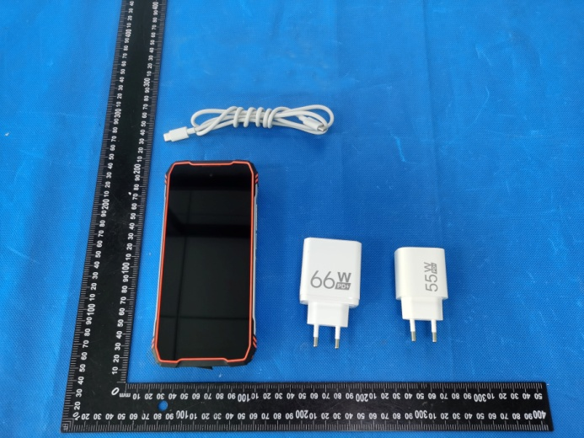

RechargeableLi-ionBattery:
Model:Li536587HTT;Specification:DC 7.7V, 10000mAh, 77Wh; Manufacturer:ShenzhenHuatiantongTechnologyCo.,Ltd.

The object of the declarationdescribed above is inconformitywith theessential requirementsof therelevant Union harmonization legislation:Radio Equipment DirectiveRED(2014/53/EU).
The followingharmonizedstandardsand technical specifications have been applied:

HEALTH & SAFETY(Art. 3(1)(a)):

EN 50360:2017;
EN 50360:2017/A1:2023
EN 50566:2017;
EN 50566:2017/A1:2023
EN IEC/IEEE 62209-1528:2021
EN 62479:2010
EN IEC 62368-1:2020+A11:2020

EMC(Art. 3(1)(b)):

ETSI EN301489-1V2.2.3(2019-11)
ETSI EN301489-3V2.3.2(2023-01)
ETSI EN301489-17V3.2.4(2020-09)
ETSI EN301489-19V2.2.1(2022-09)
ETSI EN301489-52V1.2.1(2021-11) EN 55032:2015+A1:2020
EN 55035:2017+A11:2020

EN IEC 61000-3-2:2019+A1:2021 EN 61000-3-3:2013+A2:2021
Radio Spectrum(Article3.2):

EN 301511V12.5.1(2017-03);

EN 301908-1V15.2.1(2023-01)

EN 301908-2V13.1.1(2020-06)

EN 301908-13V13.2.1(2022-02);
EN 301 908-25 V15.1.1 (2024-10)

EN 300328V2.2.2(2019-07);

EN 301893V2.1.1(2017-05);

EN 300440V2.2.1(2018-07);

EN 303413V1.2.1(2021-04);

EN 303345-1V1.1.1(2019-06);

EN 303345-3V1.1.1(2021-06);

EN 300330 V2.1.1(2017-02)

NOTIFIEDBODY:

Name:DERYCOM CERTIFICATION SERVICES, INC.
Address:1100 FalconAvenueGlencoe,Mn55336 IdentificationNumber:3052
EU-typeexaminationcertificatenumber:JEC-35

RF Specification:
Function | Operation Frequency | Max RF output power:
BLE 1M | 2402MHz–2480MHz | 0.85 dBm
BLE 2M | 2404MHz–2478MHz | 0.92 dBm
BT(BR+EDR) | 2402MHz–2480MHz | 5.64 dBm
WIFI 802.11b/g/  n/ax(HT20/40) | 802.11b/g/n/ax(20MHz): 2412~2472MHz;  802.11n/ax(40MHz):2422~2462MHz | 14.38dBm
Wi-Fi  5.2G(802.11a/n20/n40/ac20/ac40/ac80/ax20/ax40/ax80) | 802.11a/ n20/ac&ax 20:5180MHz~5240MHz  802.11 n40/ac&ax 40:5190MHz~5230MHz  802.11 ac&ax 80:5210MHz | 13.18 dBm
Wi-Fi  5.8G(802.11a/n20/n40/ac20/ac40/ac80/ax20/ax40/ax80) | 802.11a/ n20/ac&ax 20:5745MHz~5825MHz  802.11 n40/ac&ax 40:5755MHz~5795MHz  802.11 ac&ax 80:57750MHz | 13.63 dBm
GSM/GPRS/EGPRS 900 | TX(Uplink):880M‐915MHZ;  RX(Downlink):925M‐960MHZ | 31.96 dBm
GSM/GPRS/EGPRS 1800 | TX(Uplink):1710M‐1785MHZ;  RX(Downlink):1805M‐1880MHZ | 28.73 dBm
WCDMA B1 | TX(Uplink):1920-1980MHz;  RX(Downlink):2110-2170MHz | 23.6 dBm
WCDMA B8 | TX(Uplink): 880-915MHz;  RX(Downlink):925-960MHz | 22.74 dBm
LTE FDD B1 | TX(Uplink):1920-1980MHz;  RX(Downlink):2110-2170MHz | 23.00dBm
LTE FDD B3 | TX(Uplink) :1710-1785MHz;  RX(Downlink):1805-1880MHz | 23.28 dBm
LTE FDD B7 | TX(Uplink) :2500-2570MHz;  RX(Downlink):2620-2690MHz | 22.6 dBm
LTE FDD B8 | TX(Uplink): 880MHz to 915 MHz  RX(Downlink): 925 MHz to 960 MHz | 24.31 dBm
LTE FDD B20 | TX(Uplink): 832MHz~862MHz;  RX(Downlink):791MHz~821MHz | 24.38 dBm
LTE FDD B28 | TX(Uplink): 703 MHz to 736MHz  RX(Downlink): 758 MHz to 791 MHz | 24.16 dBm
NR FDD n1: | Uplink: 1920 MHz to 1980MHz  Downlink: 2110 MHz to 2170 MHz | 23.62 dBm
NR FDD n3: | Uplink: 1710 MHz to 1785 MHz  Downlink: 1805 MHz to 1880 MHz | 24.2 dBm
NR FDD n8: | Uplink: 880 MHz to 915 MHz  Downlink: 925 MHz to 960 MHz | 23.79 dBm
NR FDD n20: | Uplink: 832 MHz to 862 MHz  Downlink: 791 MHz to 821 MHz | 23.85 dBm
NR FDD n28: | Uplink: 703 MHz to 748 MHz  Downlink: 758 MHz to 803 MHz | 23.81 dBm
NR TDD n40: | Uplink & Downlink: 2300 MHz to 2400 MHz | 24.05 dBm
NR TDD n77: | Uplink & Downlink: 3300 MHz to 4200 MHz | 25.52 dBm
NR TDD n78 | Uplink & Downlink: 3300 MHz to 3800 MHz | 25.09 dBm
NFC | 13.56MHz | -2.89dBuA/m@10m
FM | Rx(Downlink): 87.5MHz~108MHz | --
GPS | Rx(Downlink): 1.57542GHz&1.17645GHz | --
Tests for SAR are conducted using standard operating ositions with the device transmittingatits
highest certified power level in all tested frequency bands. The maximum SAR values tested on this device when used in its normal position at the ear and when used close to the body(ataminimumdistance of 5mm/0mm) are:

Max SAR Value(W/kg)  Limitis 2.0(W/kg) for10-g | 10-gHead | 0.353
Max SAR Value(W/kg)  Limitis 2.0(W/kg) for10-g | 10-gBody | 0.702
Limitis 4.0(W/kg) for10-g | 10-gMemberDAS | 2.318

Technical fileheld by: DOKE COMMUNICATION (HK) LIMITED

19H MAXGRAND PLAZANO 3 TAI YAU STREETSAN PO KONGKL

Signed for and on behalf of: DOKE COMMUNICATION (HK) LIMITED

Nameand Title: | zhang.liuwei/Manager
Address: | 19H MAXGRAND PLAZANO 3 TAI YAU STREETSAN PO KONGKL



SignatureofAuthorizedPerson
2025-10-20

